- Exploratory Data Analysis

1 Summary of Statistics and Distribution

Price Distribution by Neighbourhood
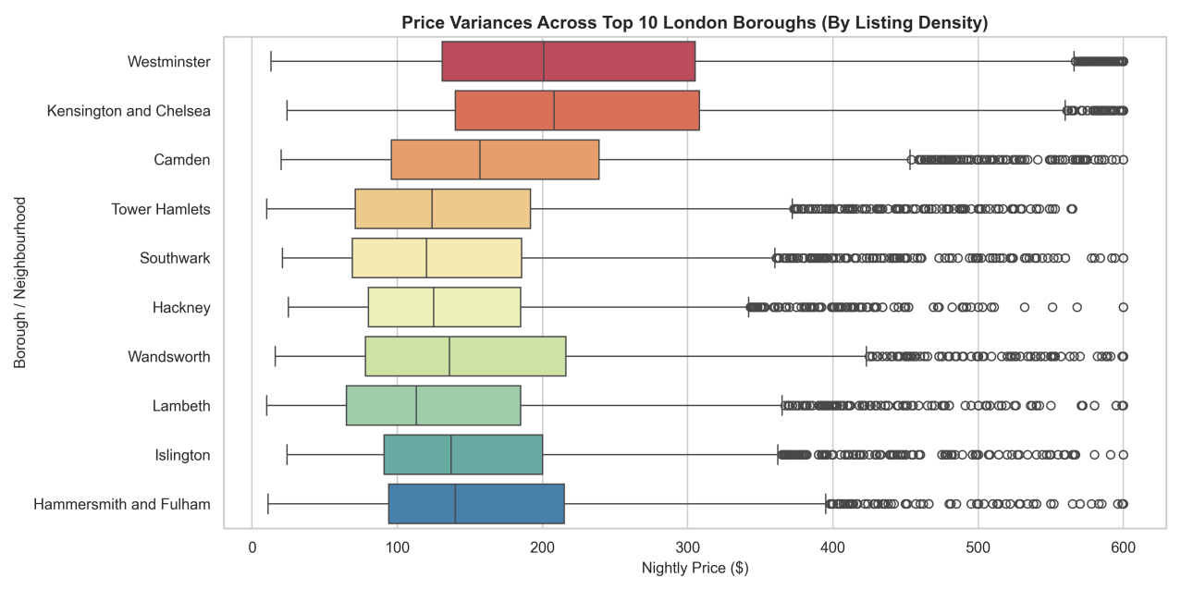
Plot 1 isolates geographic pricing gradients, revealing that premium location premium dynamics dictate London's real estate values. Westminster and Kensington and Chelsea clearly anchor the luxury tier, commanding much higher median values and broader interquartile spreads that push past $\$300$. In contrast, high-density boroughs like Tower Hamlets and Hackney showcase highly compressed, budget-friendly price boxes, highlighting a clear structural divide between central commercial/tourist hotspots and more residential, eastern boroughs.

Price Distribution by Listings
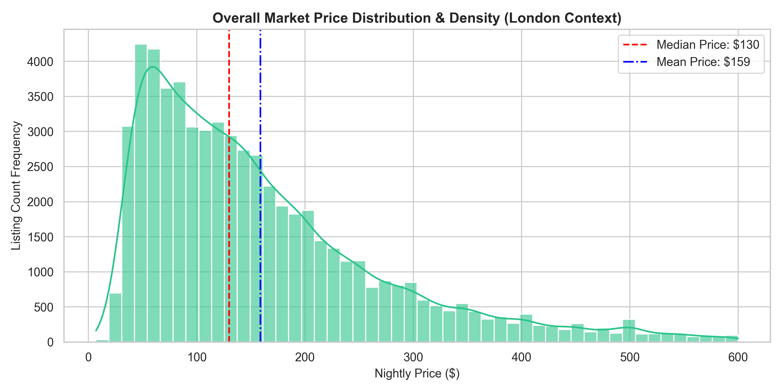
Plot 2 demonstrates a classic right-skewed market distribution, where the bulk of London's listing inventory is heavily concentrated in the affordable $\$50$ to $\$120$ range. The significant gap between the Median Price ($\$130$) and the Mean Price ($\$159$) mathematically proves the strong pull of high-end luxury listings. This long right tail indicates that while casual, high-volume consumer demand defines the market baseline, a small segment of premium inventory disproportionately drives up overall revenue averages.

Price distribution by Room type
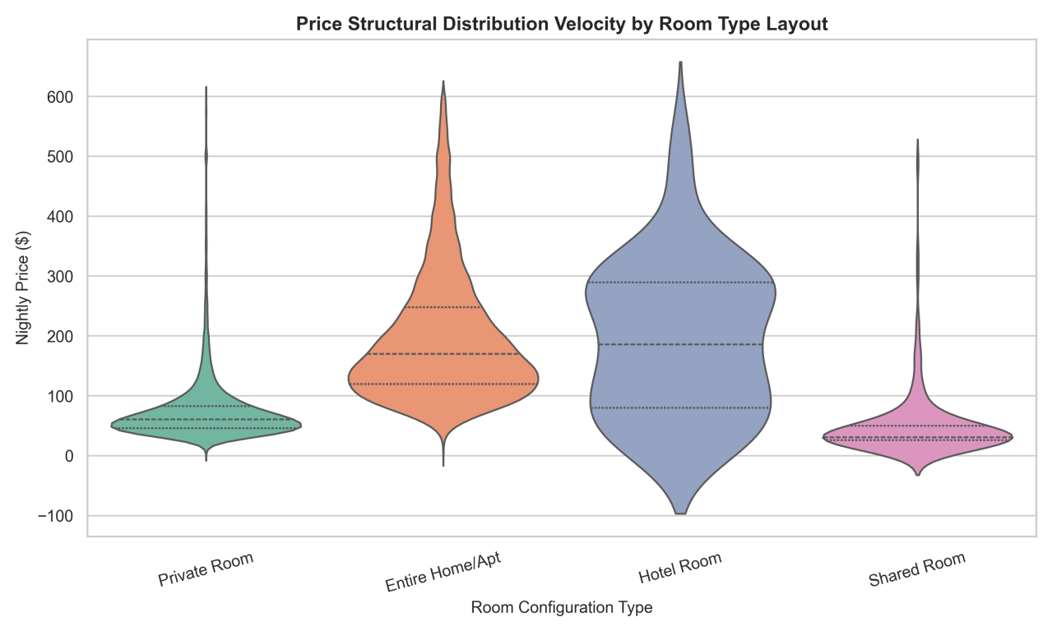
Plot 3 reveals severe right-skewness and luxury outliers across individual room categories. While Shared and Private Rooms are densely clustered at a budget floor below $100, their distributions stretch into long, thin tails up to the $600 cap. Conversely, Hotel Rooms display a much wider, more balanced distribution with higher median baselines, reflecting standardized commercial pricing rather than the bottom-heavy clustering of home-sharing inventory.

Price distribution by Property type
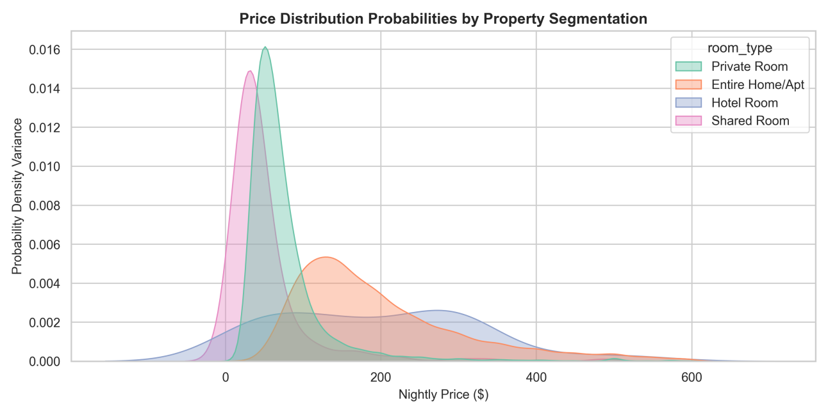
Plot 4 isolates market concentration, showing that Shared and Private Rooms peak sharply and earliest (at $30 and $50, respectively), capturing the high-density budget floor. In contrast, Entire Homes/Apartments flatten out and shift completely rightward into a wide pricing plateau between $150 and $350, demonstrating that upgrading to a full property layout moves an asset into an entirely different, more elastic economic tier.

Hosting Power Law Distribution
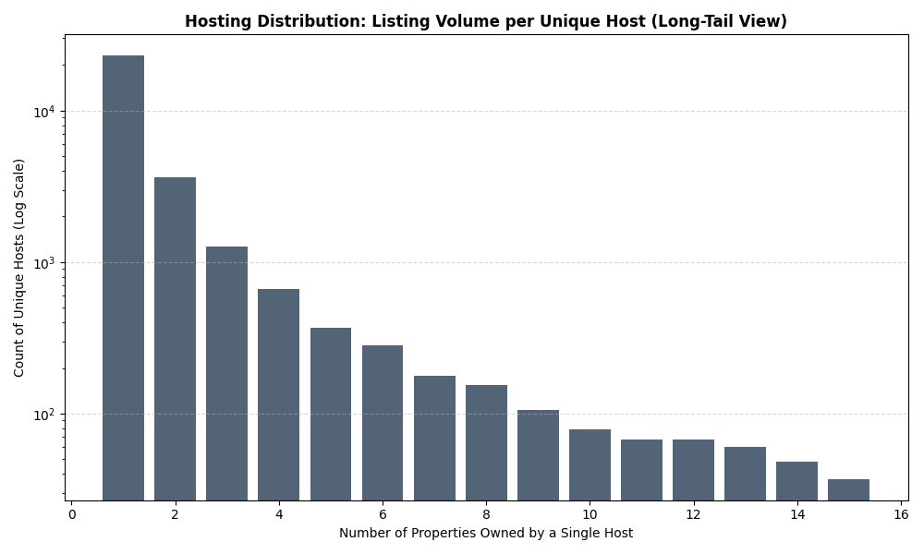

This plot demonstrates Power Law Dynamics (long-tail distribution) within the marketplace. The vast majority of unique hosts occupy the first bar, owning exactly one property (casual, mom-and-pop operators). As the number of properties increases, the host count drops exponentially. This structural steepness proves a high market concentration: while individual hosts dominate by volume, a tiny fraction of professional property management firms manage extensive portfolios.

Distribution of Review Pacing
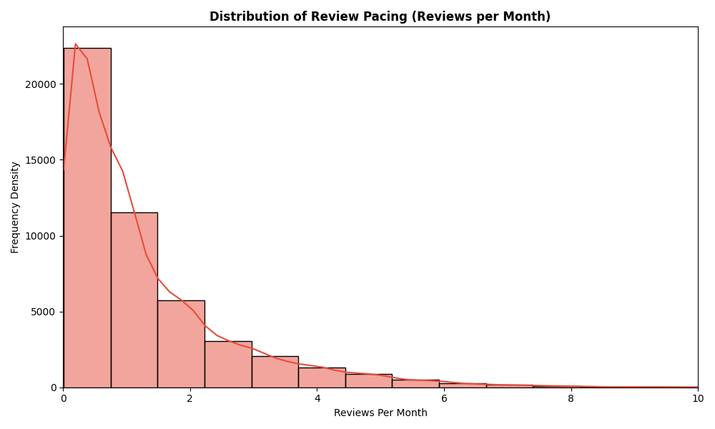
This distribution demonstrates that user engagement is heavily skewed toward low-frequency pacing. The vast majority of listings accumulate fewer than two reviews per month, creating a rapid exponential decay curve. This steep right-skew indicates a hyper-active group of highly booked, top-tier properties driving the rightward tail, while the substantial clustering near zero reveals a large baseline of stagnant or highly seasonal inventory that rarely captures guest conversion events.

- Seasonal Trends

- Price Variance
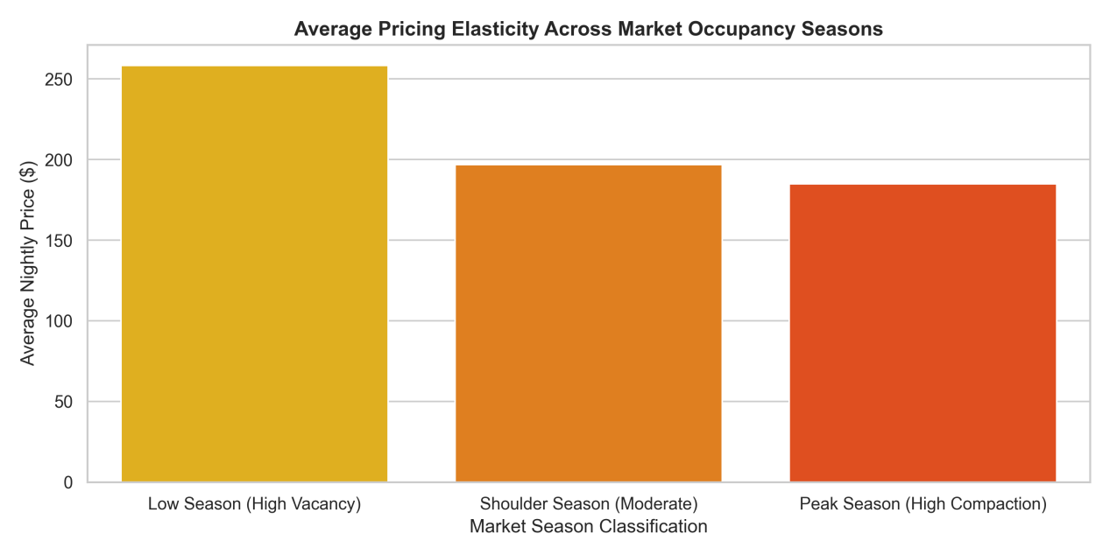
This analysis reveals an inverse relationship between listing availability and average pricing. Highly commercialized, luxury properties dominate the Low Season (High Vacancy) mix with rigid, premium pricing floors that hold steady at roughly $260 despite lower market volume. Conversely, during Peak Season (High Compaction), a massive influx of cheaper, casual "mom-and-pop" inventory floods the platform, diluting the market-wide baseline down to an average of $185 despite soaring consumer demand.

- Minimum Nights Policy

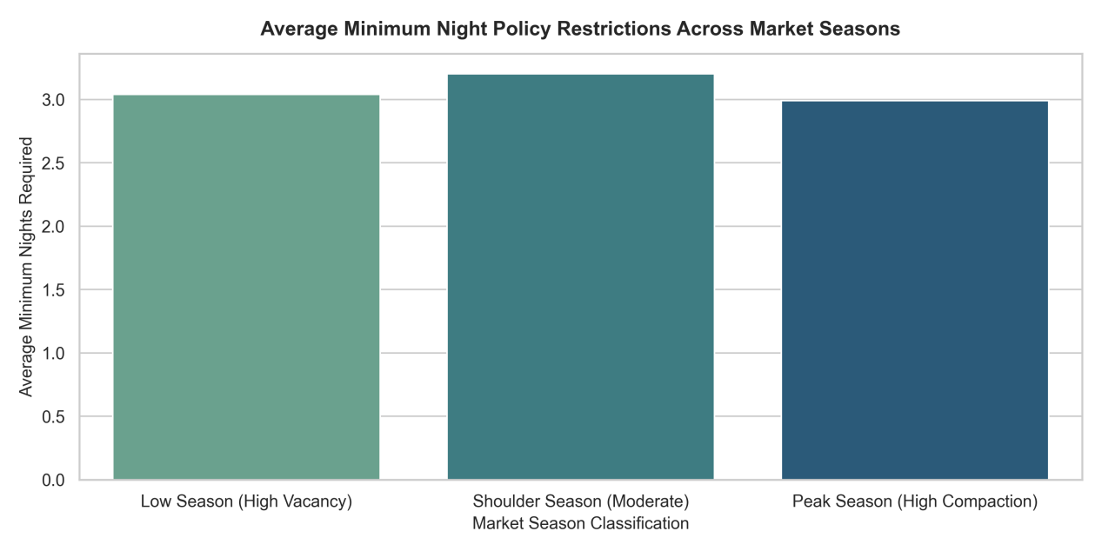
This analysis reveals that average minimum night restrictions remain remarkably uniform across London's seasonal cycles, hovering tightly around a 3-night baseline ($3.0$ to $3.2$ nights) regardless of market compaction. Rather than dynamically adjusting stay-length requirements to match seasonal demand spikes or vacancies, hosts maintain a rigid structural baseline. This stability indicates that operational factors—such as local council regulatory caps (like London's 90-night rule), standard cleaning turnover costs, and a collective preference for mid-length tourist stays—outweigh short-term seasonal pricing adjustments.

- Host and Supply side analysis

- Portfolio Size
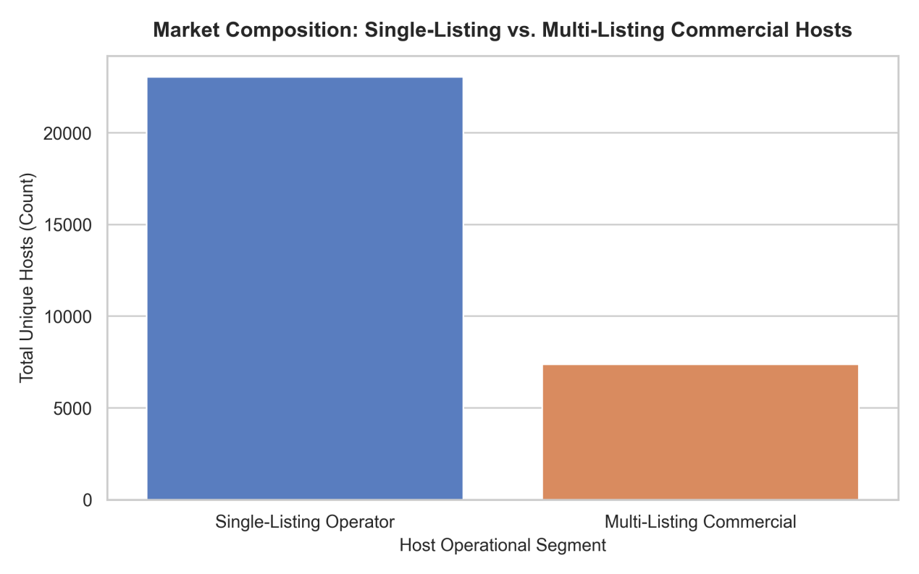
Ecosystem composition reveals a distinct structural boundary between casual and professionalized supply. While single-property owners represent the higher absolute volume of unique host accounts, commercial multi-listing operators control a disproportionately massive share of active inventory. This consolidation highlights a highly mature, professionalized market where corporate operators utilize economies of scale to dominate overall platform supply.

- Pricing strategies of professional hosts vs. casual hosts.
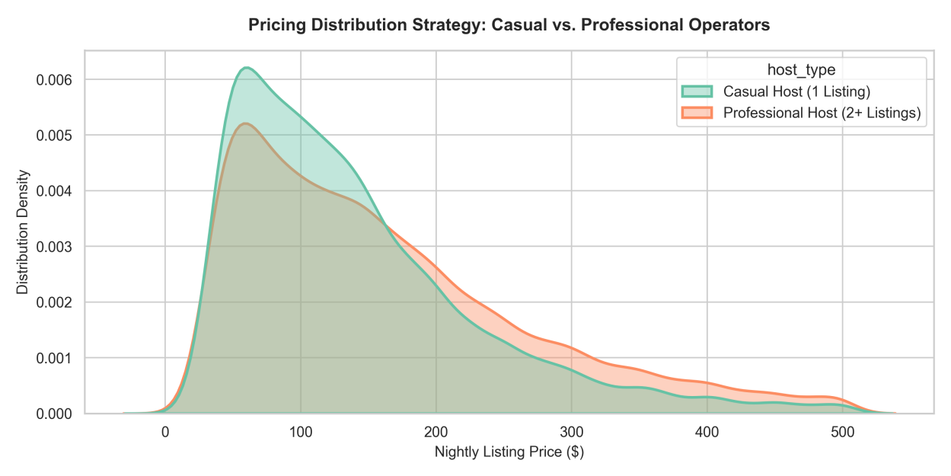
Professional hosts leverage algorithmic dynamic pricing and structural pricing floors to offset corporate overhead. This shifts their pricing distribution curve rightward, showing a higher median baseline and strategic pricing peaks designed to capture premium yields during high-demand windows.Casual hosts exhibit a tighter, left-skewed pricing distribution concentrated around lower, highly localized baselines. Lacking automated yield-management software, these operators utilize static, defensive pricing strategies that prioritize predictable occupancy over active revenue optimization.
- Concentration of market supply
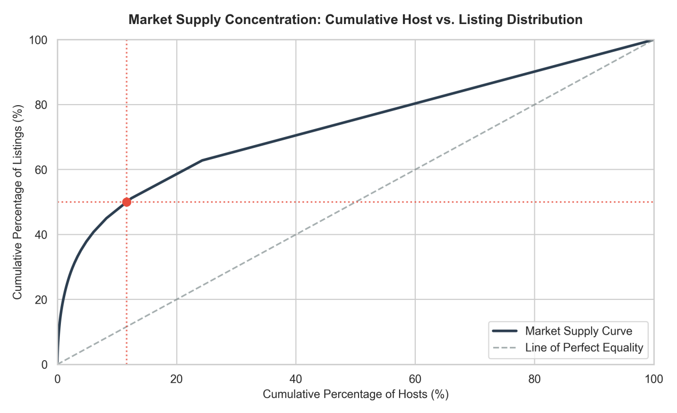

The cumulative distribution curve demonstrates a classic Pareto imbalance: a tiny minority of top-tier commercial hosts control the clear majority of active listings. This operational configuration confirms that while casual hosts comprise the numerical baseline of individual accounts, the platform's supply architecture is fundamentally shaped and driven by a consolidated layer of professionalized operators managing extensive multi-property portfolios.

- Relationship between review count and price
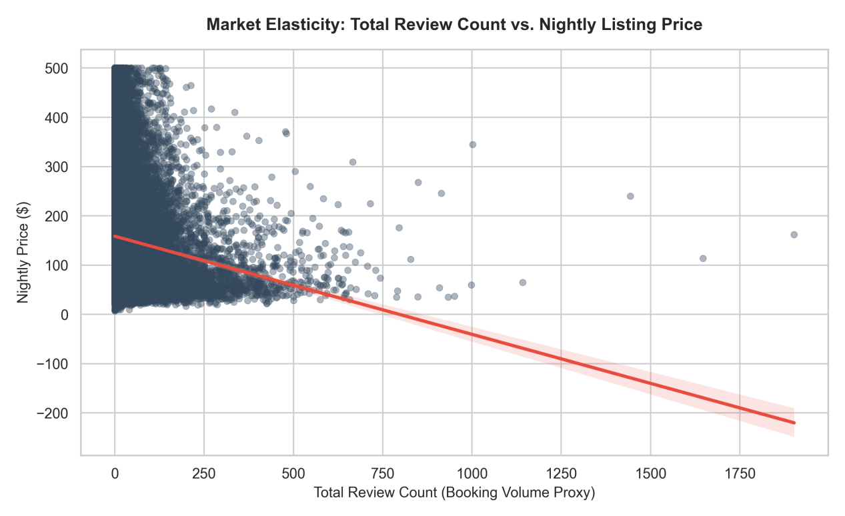
Reveals a strong inverse relationship between pricing floors and booking velocity. Listings with substantial review volumes cluster almost exclusively within the sub-$150 price range, proving that competitive pricing is the core driver for high asset turnover.

